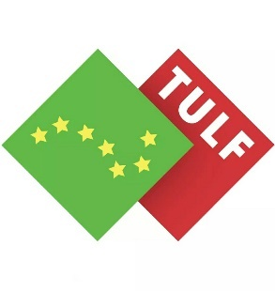
PRESS RELEASE

TRADE UNION LEFT FORUM – WORKERS’ RIGHTS CAMPAIGN

January 2020 – The Trade Union Left Forum will launch its ‘Workers’ Rights Campaign’ on Saturday 18th January 2020 in Connect Trade Union head office, 6 Gardiner Row, Dublin 1, at 2pm

The campaign is demanding the abolition of the 1990 Industrial Relations Act and its replacement with a ‘Fair Employment Act’ that guarantees:

- The rights of union access to all workers
- The right to union recognition
- Full Collective Bargaining rights
- The end to the voluntarist industrial relations system

Four trade unions have already adopted as policy the demand to abolish the 1990 Industrial Relations Act; namely, Mandate Trade Union, Connect, Unite the Union, and Fórsa (Civil Service Section). These unions have a combined membership of 153,250 workers. It is expected that other unions will adopt the same position at their forthcoming Biennial Delegate Conferences this year.

The 1990 Industrial Relations Act is the worst dilution of workers’ rights in the history of this state. As a result, trade union density – despite some recent tentative improvements – remains at an all-time low of approximately 24%. This has resulted in low pay, minimum hour contracts, the gig economy, bogus self-employment, and a general race to the bottom in workers’ rights. Ireland now has the worst levels of low pay in the EU and the second worst in the OECD. The 1990 Act was brought in during social partnership and needs to be abandoned, just as social partnership was.

As things currently stand, all power is on the side of the employers. It’s time the balance of power was tipped back towards workers. In order to achieve this, the 1990 Industrial Relations Act must be abolished now!

ENDS

For enquiries contact:

Jimmy Doran 0879176292

